**Workflow Functional Document**

|  |  |
| --- | --- |
| **Application** | NGERP - Centra |
| **Workflow** | Procure To Pay |
| **Workflow Item Name** | Direct NTA AP Invoice – Charge / Description. |

**Description:**

In NGERP System, Direct NTA AP Invoice(With Charge/Description) is created (or) imported to store the details of the NTA AP Invoice and NTA AP Payment is created and then the Invoice will be allocated with Payment.

**Workflow Process:**

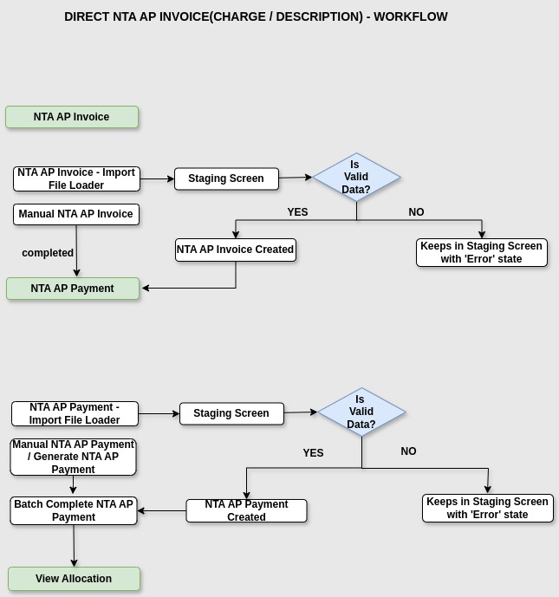

**Business Rules:**

* We can create NTA AP Invoice(With Charge/Description) document by two ways :

1. **Import File Loader** – Importing NTA AP Invoice records using Import File Loader Function will move them into Staging Screen.In Staging Screen, there are some Validations. If the Validations are correct, then the NTA AP Invoice will be created with ‘In Progress’ State.

2. **Manual NTA AP Invoice** – We can also create NTA AP Invoice documents manually.

Then, the NTA AP Payment document will be created.

* We can create NTA AP Payment document by three ways :

1. **Import File Loader** – Importing NTA AP Payment records using Import File Loader Function will move them into Staging Screen. In Staging Screen, there are some Validations. If the Validations are correct, then the NTA AP Invoice will be created with ‘In Progress’ State.

2. **Generate NTA AP Payment –** We can also create NTA AP Payment using Generate NTA AP Payment Form. By creating NTA AP Payment using Generate AP Payment,   
 Allocation will be created automatically with ‘In Progress’ state.

3. **Manual NTA AP Payment** – We can also create NTA AP Payment documents manually.

Then, the NTA AP Payment will be allocated with NTA AP Invoice.

* **View Allocation –** Need to allocate NTA AP Invoice document with NTA AP Payment document.